Industrial Computer
QY-U300

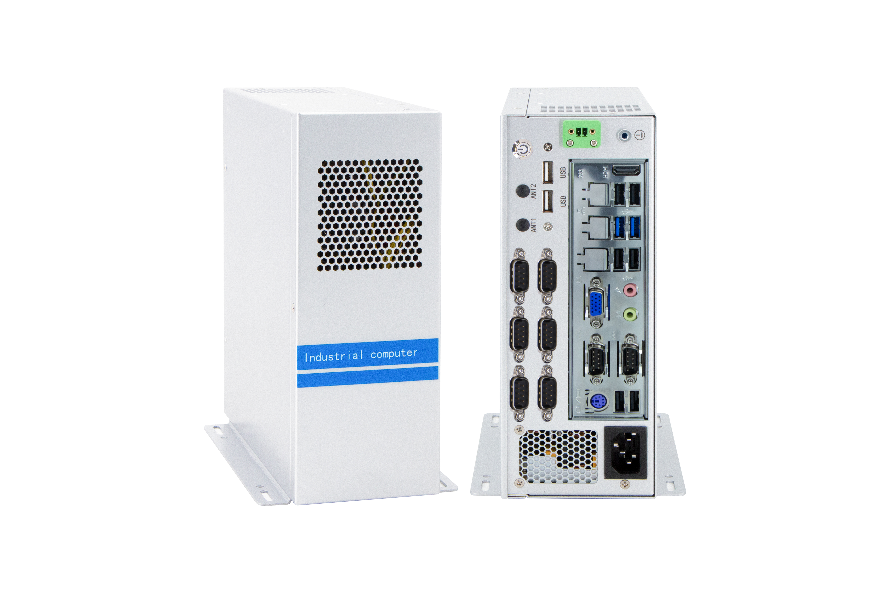

Products Features:
- Industrial-Grade Industrial Computer
- Support Mini-ITX Mother Board
- Intel 4/6/7/8/9/10/12/13/14th-i3/i5/i7/i9 desktop CPU
- Standard 1U ATX power, 300w to 1300w
- More expansion slots, Mini PCIE / M.2
- Support remote power on and off
- -30℃~70℃ Temperature Can Keep 24/7 Work Stably
- Anti-Static, Anti-Pulse, Anti-Surge, Anti-Radiation
QY-U300
1-1.B81 Mother Board Specification:
Mother Board Model | QY-B81AH-H
Chipset | Intel B81, Support Intel Core 4th-i3/i5/i7 / Pentium / Celeron Desktop CPU, LGA 1150
Memory | Support DDR3-1333/1600 MHz, 2*non-ECC U-DIMM Slots, Up to 16GB
Storage | 1*MSATA SSD slot  1*SATA 3.0 SSD slot  1*SATA 2.0 SSD slot
Display | 1*HDMI: Resolution max up to 3840*2160@30hz  1*VGA: Resolution max up to 1920*1200@60Hz
Expansion | 1*Mini PCIE slot, support 4G and WIFI module
Ethernet | 2*Realtek 1Gbps LAN Chip (10 / 100 / 1000 Mbps, RJ-45 Type)
USB | 6*USB 3.0 (Type-A)  10*USB 2.0 (Header)
COM | 2*RS-232 (DB9 Type)  1*RS-232 / 485 (Box)  3*RS-232 (Box)  4*RS-232 (Header)
Audio | 1*Line-out+1*Line-in+MIC
Mother Board Type | Mini-ITX

QY-U300
1-2.H110 Mother Board Specification:
Mother Board Model | QY-B11AH-A
Chipset | Intel H110, Support Intel Core 6/7/8/9th-i3/i5/i7 / Pentium / Celeron desktop CPU, LGA 1151
Memory | Support DDR4-1866/2133 MHz, 2*non-ECC U-DIMM Slots, Up to 32GB
Storage | 1*MSATA SSD slot  2*SATA3.0 SSD slots
Display | 1*HDMI: Resolution max up to 4096*2160@24Hz  1*VGA: Resolution max up to 1920*1200@60Hz
Expansion | 1*Mini PCIE slot, support 4G and WIFI module
Ethernet | 2*Realtek GbE LAN Chip (10 / 100 / 1000 Mbps, RJ-45 Type)
USB | 8*USB 3.0 (Type-A)  2*USB 2.0 (Type-A)  6*USB 2.0 (Header)
COM | 2*RS-232 (DB9 Type)  1*RS-232 / 485 (Header)  7*RS-232 (Header)
Audio | 1*Line-out+1*MIC
Mother Board Type | Mini-ITX

Mother Board Model | QY-H472A-X
Chipset | Intel H470 Support Intel Core 10th-i3/i5/i7/i9 / Pentium / Celeron desktop CPU, LGA 1200
Memory | Support DDR4-2133/2400/2666/2933 MHz, 2*U-DIMM Slots, Up to 64GB
Storage | 1*M.2 SATA SSD slot  1*SATA3.0 SSD slot
Display | 1*VGA: Resolution max up to 1920*1200@60Hz  1*HDMI: Resolution max up to 4096*2160@30Hz
Expansion | 1*M.2 Key-E slot, support WIFI module
Ethernet | 2*Realtek GbE LAN Chip (10 / 100 / 1000 Mbps, RJ-45 Type)
USB | 6*USB 3.0 (Type-A)  4*USB 2.0 (Type-A)  2*USB 2.0 (Header)
COM | 10*RS-232 (Header)
Audio | 1*Line-out+1*MIC
Mother Board Type | Mini-ITX
QY-U300
1-3.H470 Mother Board Specification:

Mother Board Model | QY-12S2A-H610-X
Chipset | Intel H610, Support Intel Core 12/13/14th-i3/i5/i7/i9 / Pentium / Celeron desktop CPU, LGA 1700
Memory | Support DDR4-3200 MHz, 2*non-ECC U-DIMM Slots, Up to 64GB
Storage | 1*M.2 NVME SSD slot  1*SATA 3.0 SSD slot
Display | 1*VGA: Resolution max up to 1920*1200@60Hz  1*HDMI: Resolution max up to 4096*2160@30Hz
Expansion | 1*M.2 Key-E slot, Support WIFI module
Ethernet | 2*Realtek RTL8111H GbE LAN Chip (10 / 100 / 1000 /2500 Mbps, RJ-45 Type)
USB | 4*USB 3.2 (Type-A)  6*USB 2.0 (Type-A)  2*USB 2.0 (Header)
COM | 10*RS-232 (Header)
Audio | 1*Line-out+1*MIC
Mother Board Type | Mini-ITX
QY-U300
1-4.H610 Mother Board Specification:

QY-U300
2.Device Specification:
Power Input | 1U ATX Power Module (300w / 500w / 800w / 1000w / 1300w)
Power Input | Support Auto-Start
Working Temperature | -30℃~70℃, Support 24/7 Working
Structure | Fully Enclosed Aluminum Alloy Material
Heat Dissipation | Fan Design
Installation | Desktop / Embedded
Size | 90mm*201mm*233.5mm
System | Windows and Linux
Mother Board Type | Mini-ITX
GPU | Non-support

QY-U300
3.Ordering Information:
Model | Chipset | CPU | LAN | USB | COM | RAM | Display | SSD | Expansion
QY-U300 | B81 | 4th | 2 | 6*3.0  10*2.0 | 1*RS-232/485  9*RS-232 | 2*DDR 3  Up to 16GB | 1*HDMI  1*VGA | 1*MSATA  2*SATA | 1*Mini PCIE  1*PCIE 16x
QY-U300 | H110 | 6th/7th/8th/9th | 2 | 8*3.0  8*2.0 | 1*RS-232/485  9*RS-232 | 2*DDR 4  Up to 32GB | 1*VGA  1*HDMI | 1*MSATA  2*SATA | 1*Mini PCIE  1*PCIE 16x
QY-U300 | H470 | 10th | 2 | 6*3.0  6*2.0 | 10*RS-232 | 2*DDR 4  Up to 64GB | 1*VGA  1*HDMI | 1*M.2 SATA  1*SATA | 1*M.2  1*PCIE 16x
QY-U300 | H610 | 12th/13th/14th | 2 | 4*3.2  8*2.0 | 10*RS-232 | 2*DDR 4  Up to 64GB | 1*HDMI  1*VGA | 1*M.2 PCIE  1*SATA | 1*M.2  1*PCIE 16x

4.System Information:

CPU | System
4th / 6th / 7th | Windows 7 / 10 and Linux
8th / 9th / 10th / 12th / 13th / 14th | Windows 10 / 11 and Linux

5.Fittings Information:
QY-U300
RAM | DDR 3 | 4GB / 8GB
RAM | DDR 4 | 4GB / 8GB / 16GB / 32GB
SSD | MSATA | 64GB / 128GB / 256GB / 512GB / 1TB
SSD | M.2 NVME/SATA | 128GB / 256GB / 512GB / 1TB / 2TB / 4TB
SSD | SATA | 120GB / 128GB / 240GB / 256GB / 480GB / 512GB / 960GB / 1TB / 2TB / 4TB
GSM Module | 4G | 4G+GPS
WIFI Module | 7260AC / AX210
ATX Power | 300w / 500w / 800w / 1000w / 1300w

6.Package List:

Power Cable | 1*Power Cable

7.Dimensions:
QY-U300

